INTERNATIONAL ASSOCIATION
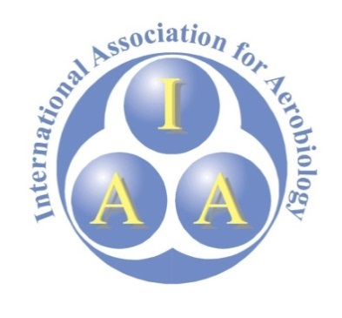
FOR AEROBIOLOGY (IAA)

GRANT APPLICATION FORM

13th International Conference on Aerobiology (ICA-2026)
25–29 November 2026, Kolkata, India

The Grant
The International Association for Aerobiology is offering 5 grants to support PhD students to travel to and participation in the 13th International Conference on Aerobiology (ICA-2026), 25–29 November 2026, in Kolkata, India. Each grant will include:
- Payment of the conference registration fee direct to the conference organiser.
- Payment of EUR1000 to support travel costs (this payment will be made electronically to the grantee’s bank account at the end of the conference upon confirmation of their attendance and participation at the conference).

Eligibility Criteria
- The applicant must be a member of the International Association for Aerobiology at the time of application (see https://iaaerobiology.org/home/membership/ for details about how to become a member).
- The applicant must have submitted an Abstract to present at the 13th International Conference on Aerobiology at the time of application (see https://ica2026.co.in/index.php for details about how to submit an Abstract).
- The applicant must be a full-time PhD student at the time of application.

Application Requirements
Fill in this form and e-mail it by 29 June 2026 to the IAA Secretary, Dr Lukasz Grewling:
E-mail address: lukasz.grewling@amu.edu.pl
Use the e-mail Subject: IAA Grant Application_Family name

Your First Name:

Your Family Name:

Your Institutional E-mail:

Institution (e.g., University) Name:

We will contact your PhD Supervisor to confirm your full-time PhD student status. For this purpose, please provide:

Your PhD Supervisor’s Title, First Name, and Family Name:

Your PhD Supervisor’s Institutional E-mail:

Briefly list below your prior university qualifications and up to 5 journal articles that you have authored. Do not exceed this page.

Prior University Qualifications (include name of degree, university, and year awarded)

Up to 5 journal articles that you have authored (include standard reference details, including the full DOI address)

Applicants will be informed of the outcome by email by 17 July 2026.

